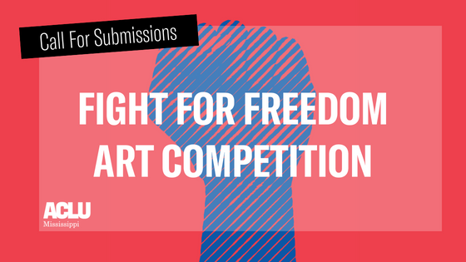
Submission Application
All submissions must include an application and cover sheet with the title, size/word count/time length, category & medium, a brief description (no more than 150 words), and a short bio about the artist written in 2nd person (no more than 250 words). Word and pdf documents accepted only.
Name Age
_____________________________________________________________________________
City & County of Residence
_____________________________________________________________________________
School (if applicable)
_____________________________________________________________________________
Submission Title
_____________________________________________________________________________
Category of Submission (Place an “x” to the left of your category)
___ Visual Art ___ Poetry ___ Essay ___ Spoken Word
Please sign at the bottom to signify you have read and agree to the following:
My work will be disqualified if it has been published, performed, or exhibited publicly prior to competition. I am responsible for any transportation or shipping fees. I cannot correct or alter my work after emailing my submission.
_____________________________________________________________________________
Signature
Please include this completed application with your cover sheet and submission in your email to office@aclu-ms.org with the subject line “Fight For Freedom Art Competition.” Visit www.aclu-ms.org for the Judging Criteria and Frequently Asked Question.

