School Staffing and the School-to-Prison Pipeline in Mississippi
Today’s students are experiencing record levels of depression and anxiety and many forms of trauma. School-based mental health providers — such as school counselors, social workers, psychologists, and nurses — are often the first to see children who are sick, stressed, traumatized, or have hurt themselves or others. These school-based mental health providers are critical resources for students. Their presence can result in positive outcomes for individual students and improve school safety generally.
Mental Health Professionals in Mississippi Schools:
Unfortunately, data from the U.S. Department of Education’s Civil Rights Data Collection (CRDC) indicates that Mississippi public schools face a critical shortage of school-based mental health providers.
Our schools are falling short of providing even the most minimal recommended levels of student support.

Recommended vs Actual Students-to-Staff Ratios
 | Recommended Ratio | Actual MS Ratio
Counselors | 250:1 | 432:1
Social Workers | 250:1 | 4,956:1
Psychologists | 700:1 | N/A
Nurses | 750:1 | 942:1
Recommended ratios from national professional associations;
Actual ratios from CRDC

The glaring deficit of mental health staff in schools is inexcusable, especially given the growing use of law enforcement in schools. Despite the lack of evidence that increased police presence in schools improves school safety or student outcomes, data indicates that many MS schools prioritize law enforcement rather than mental health or social services. 60-percent of students in MS attend schools that have police, but lack either a counselor, social worker, psychologist, and/or nurse.
Law enforcement presence may actually cause harm. When in schools, police officers do what they are trained to do -- which is detain, handcuff, and arrest. This leads to greater student alienation and a more threatening school climate. This dangerous combination is a central reason the most vulnerable students are being funneled into the school-to-prison pipeline.
In fact, Mississippi has the 20th highest student arrest rate in the nation.
This pattern of criminalizing schoolchildren also results in students with disabilities and students of color being disproportionately sent into the criminal system.

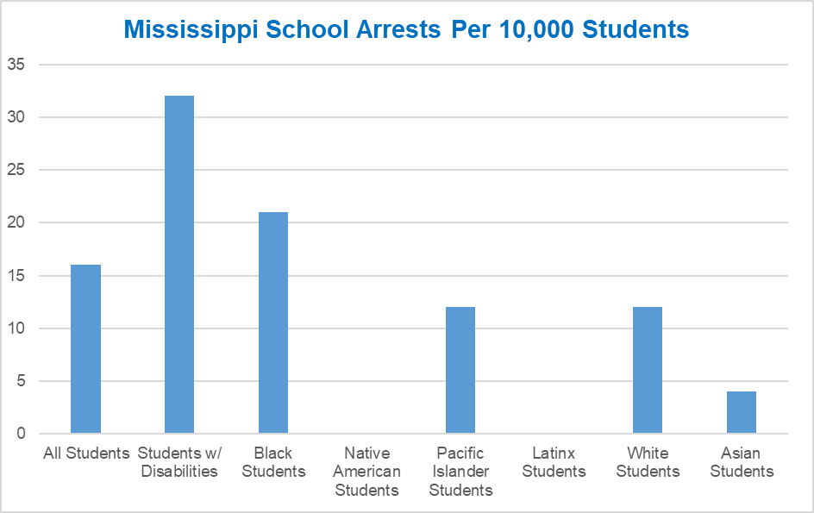
Black students in MS are more than 4 times as likely to be arrested as white students.
Students with disabilities in MS are nearly 2.5 times as likely to be arrested as students without disabilities.

There are, however, steps that can be taken to address these inequities and provide students with the supports they need.
RECOMMENDATIONS
- Increase funding for student support services, including mental health staffing and programming. Prioritize education funding for student support services over law enforcement.
- Ensure that all schools have at least the recommended staff-to-student ratios for each school-based mental health staff, including as counselors, psychologists, social workers and nurses.
- Provide equal protection for students, ensuring that school discipline and law enforcement involvement is not administered unfairly or in ways that discriminate against students of color, students with disabilities, or others who may face disparate discipline (i.e., LGBTQ students).
- Ensure that law enforcement officers are provided with comprehensive and appropriate training on critical topics, such as child/adolescent development, implicit bias, and de-escalation tactics.
- End practices like school arrests and law enforcement referrals that criminalize youth for common adolescent behaviors, including misdemeanors like disorderly conduct.
- Adopt school codes of conduct that reject zero tolerance policies for more appropriate, child-centered responses to challenging behavior.
DATA AND METHODS
Data come from the U.S. Department of Education’s Civil Rights Data Collection (CRDC), a biennial survey administered to public schools by the U.S. Department of Education’s Office for Civil Rights. Based on this data, 490,208 students were enrolled in Mississippi public schools. This and related publications use CRDC data from the 2015-2016 school year, the most recent dataset available at the time of production. Full information about methodology and limitations can be found in full report at www.aclu.org/copsandnocounselors. More information about the CRDC can be found at http://ocrdata.ed.gov.

